SRS for pipline file “ Integrated_AI_Knee_OA_Software_SRS_v2”
Very important file is “RAC_Word_File_Updated (1) SK” and SHOULD NOT BE SHARED WITH ANYONE
Our git should not be public its my major work it can be between you and me only

Take any dataset relevant to knee ROI latest YOLO or any other available online

Main dataset is OAI knee dataset
- All clinical file is its .CSV available at Osteoarthritis Initiative — NIH/NDA but we are using its mirror AVAILABLE Knee Osteoarthritis Dataset with Severity Grading — Kaggle
- UNET dataset Reference Ground Truth Mask for UNET https://github.com/yaufan/Knee_Segmentation_Database

If any git you are using should not show as we coiped the code
I have done FTA angle calculation by PCA method (code is ready with me) which is explained here “PCA_Anatomical_FTA_Detailed_Mathematical_Methodology” but it has some problems if possible if you can make it as following method will be greate out of these any option
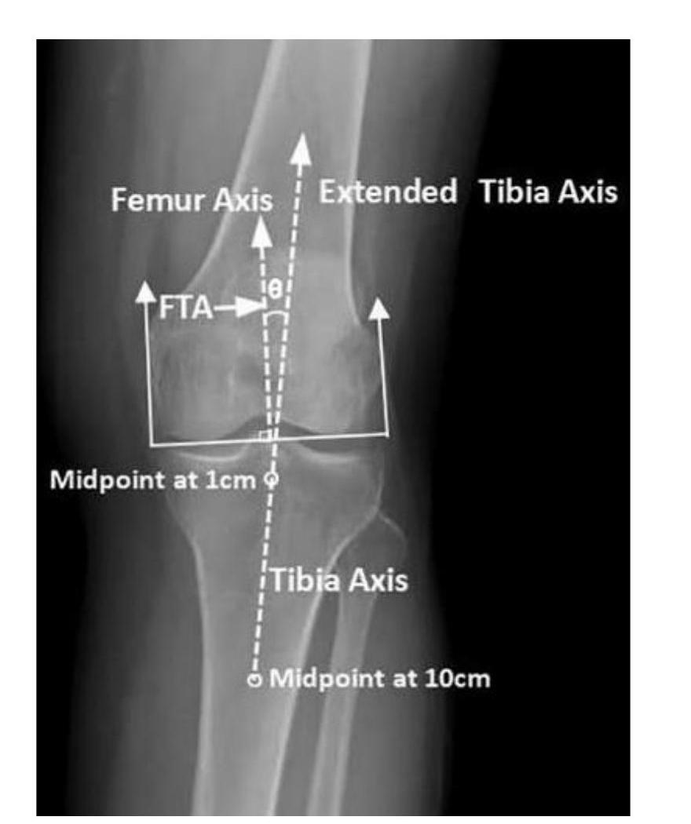 OR
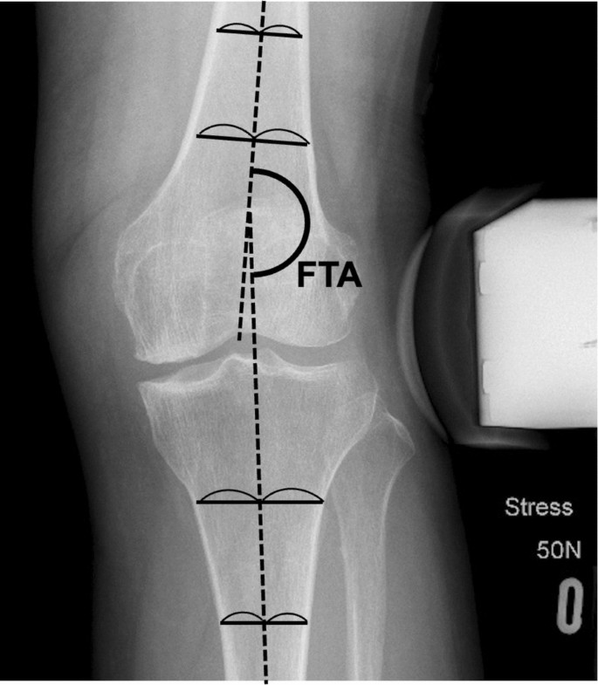
please handle preprocessing data requirements

for Monday I just need
IMAGE SEGMENTATION UNET-> KL CLASSIFICATION+FTA ANGLE CALCULATION-> CLINICAL RADIOLOGICAL DATA INTEGRATION AND PREDICTION OF TKA RISK->XAI

Remain ing things can be done later
But I thought I will send entire idea so that in one go only we can complete at least minimum deliver
IMAGE SEGMENTATION UNET-> KL CLASSIFICATION+FTA ANGLE CALCULATION-> CLINICAL RADIOLOGICAL DATA INTEGRATION AND PREDICTION OF TKA RISK->XAI
This pipline by Monday,full pipline is best

Thanks in advance

